**AquaSync**

**A Water Monitoring Application**

**Floro C. Ocero, Jr.**

**Tristan Amiel Clemen**

**Daniel Serognas**

**Joshua Formentera**

**Kennith James Pecato**

**Agnes Pamisa**

**An Object Oriented Programming Project**

Department of Information Technology

College of Engineering and Technology

University of Science and Technology of Southern Philippines – Claveria Campus

Claveria Misamis Oriental, 9004 Philippines

December 12, 2024

**I. Background of the Study**

Water is an essential resource for all aspects of life, yet its overconsumption and wastage remain significant global challenges. In response to this, AquaSync was developed as a simple and intuitive application to help individuals monitor their monthly water usage. By offering clear insights and practical tips, AquaSync aims to empower users to make informed decisions about their water consumption.

The app is designed to promote sustainable habits by enabling users to track their usage patterns and identify areas for improvement. Through this, AquaSync encourages responsible resource management, contributing to the conservation of water for future generations. It serves as a practical tool for fostering awareness and supporting users in their journey toward sustainability.

**II. Objectives**

The primary objective of AquaSync is to promote water conservation by providing individuals with an easy-to-use tool for monitoring their water usage. The app aims to raise awareness about monthly consumption patterns, encourage mindful water use, and help users adopt sustainable habits. By making water tracking accessible, AquaSync empowers users to make informed decisions and contribute to the preservation of this vital resource for future generations.

**III. Scope and Limitation of the Study**

**Scope:**This study focuses on the development of AquaSync, a desktop application designed to help users monitor their monthly water consumption. The app includes features for recording water usage, calculating the monthly total, and providing practical tips to reduce water waste. AquaSync aims to assist users in becoming more aware of their water usage patterns and making more sustainable choices. The app is intended for individual use, targeting household users who want to track and manage their water consumption effectively.

**Limitations:**

* The app does not calculate daily water usage; it focuses solely on monthly consumption tracking.
* It does not integrate with external devices or sensors to automatically track water consumption; users must manually input their data.
* The app is designed as a desktop application only and does not include mobile or web versions.
* AquaSync's recommendations and tips are general and not tailored to specific user behaviors or household setups.
* The app relies on user accuracy for data input, which may affect the reliability of its calculated insights.

**IV. Flowchart**

Figure 1: Main Flowchart

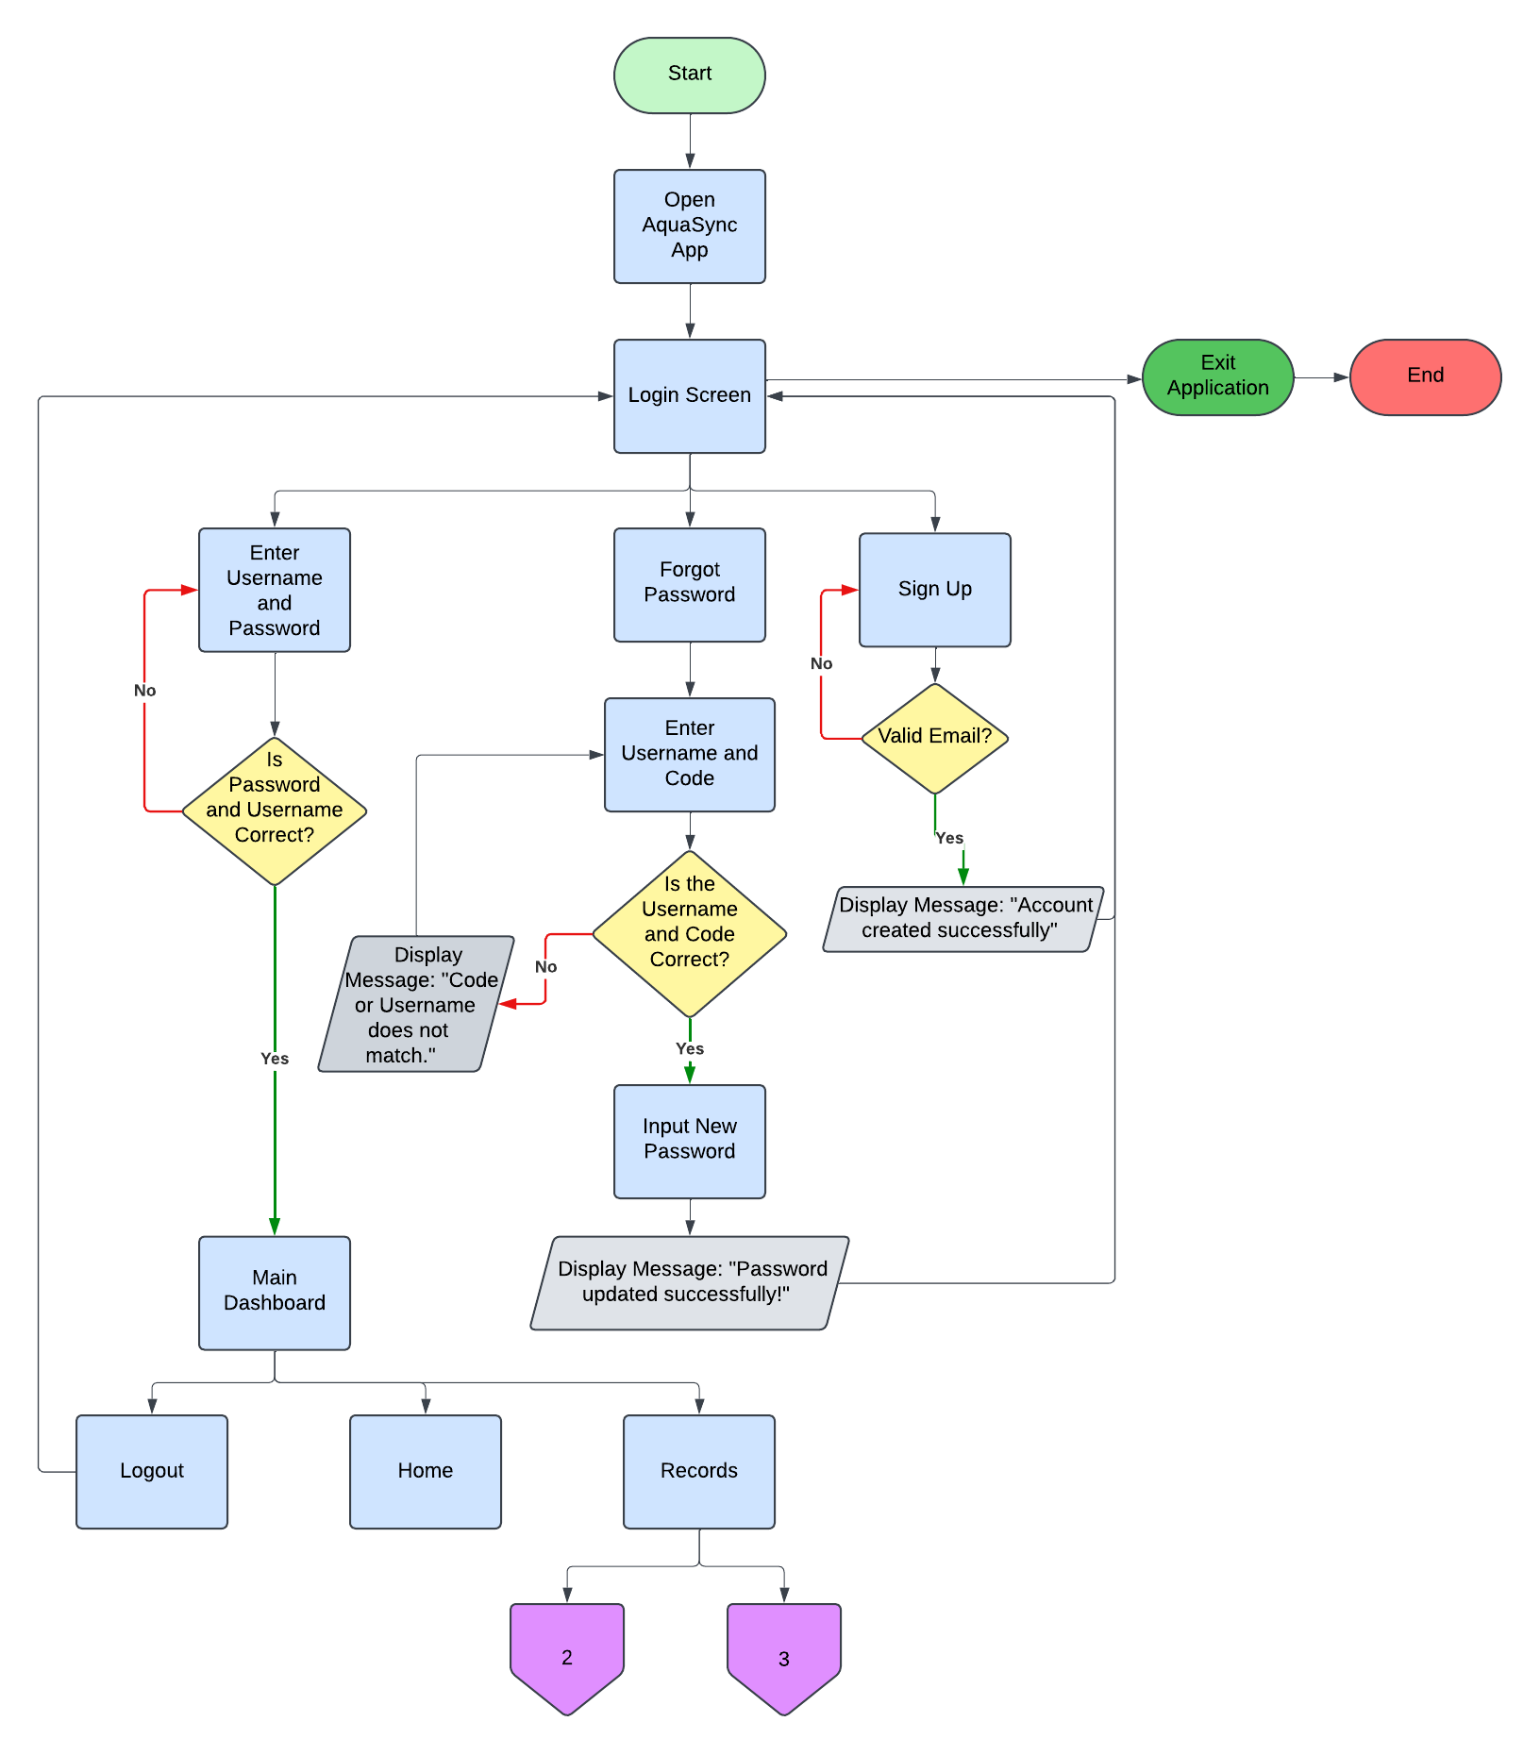

Figure 2: Records Flowchart (Adding)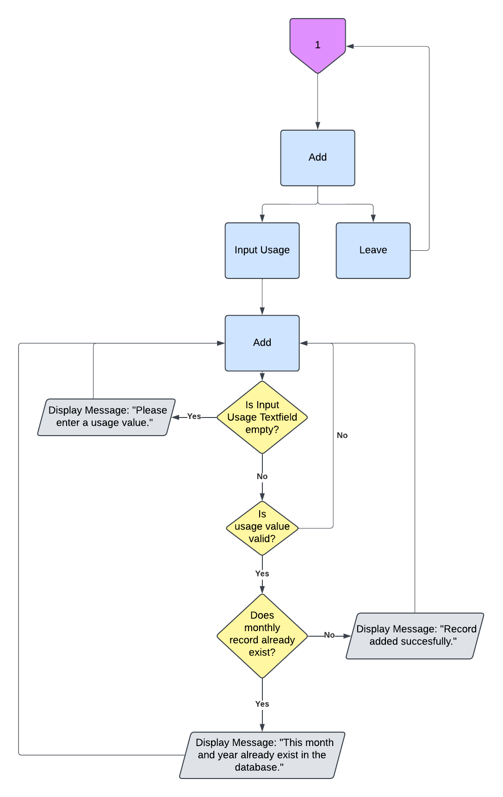

Figure 3: Record Flowchart (Edit & Delete)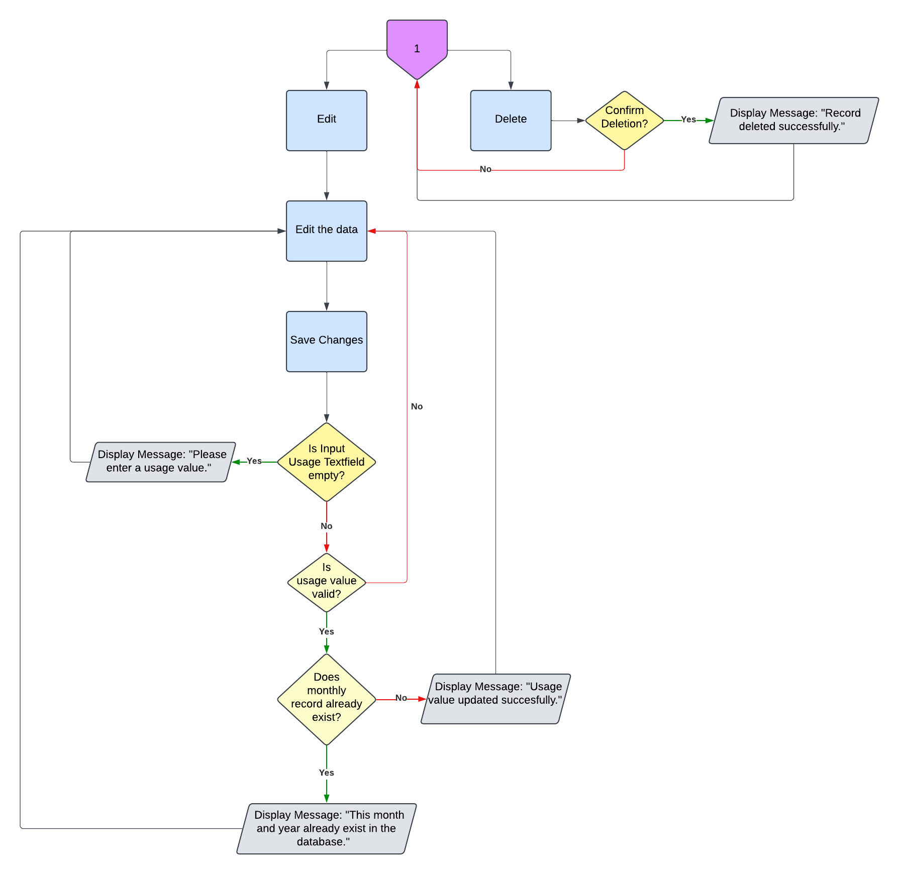

**V. Gantt Chart**

Figure 4: Gantt Chart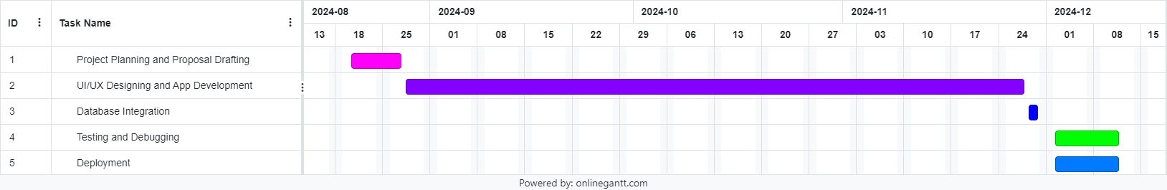

The Gantt chart outlines the timeline and key tasks for the development of AquaSync:

1. **Project Planning and Proposal Drafting**: Spanning 6 days, this phase starts on August 20, 2024, and concludes on August 27, 2024.
2. **UI/UX Designing and App Development**: The longest phase, taking 66 days, from August 28 to November 27, 2024.
3. **Database Integration**: Scheduled for 2 days, November 28–29, 2024.
4. **Testing and Debugging**: Allocated 8 days, from December 2 to December 11, 2024.
5. **Deployment**: Also lasting 8 days, this final stage overlaps with testing, occurring from December 2 to December 11, 2024.

This Gantt chart provides a clear and organized visualization of tasks, durations, and timelines to ensure the smooth execution of the project.

**VI. System Design**

Figure 5: Login Window

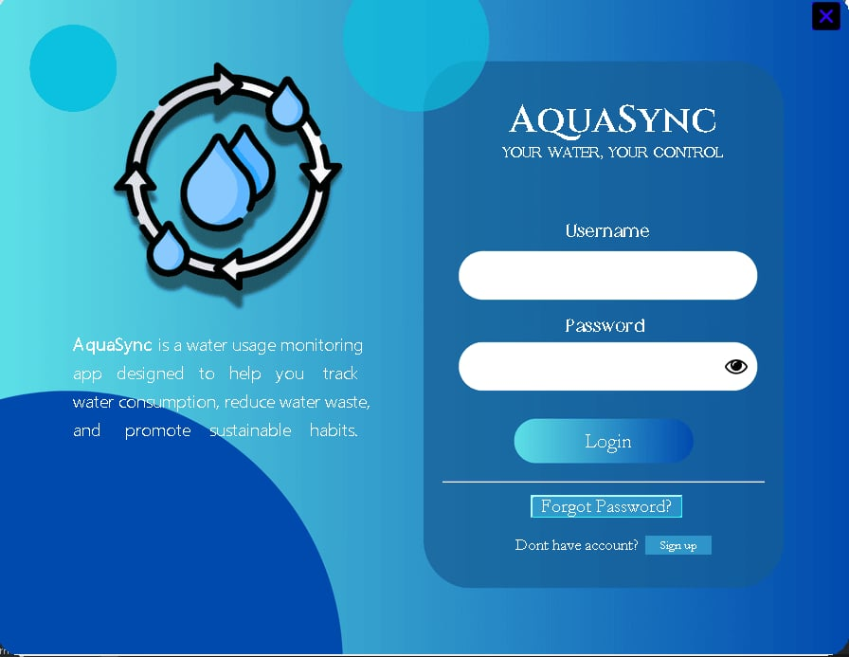

Upon launching the application, the user is presented with the login screen. If the user already has an account, they can enter their credentials to log in. In case the user has forgotten their password, they can click the "Forgot Password?" button to reset it. If the user doesn't have an account, they can click the "Sign up" button to create a new one.

Figure 6: Signup Window

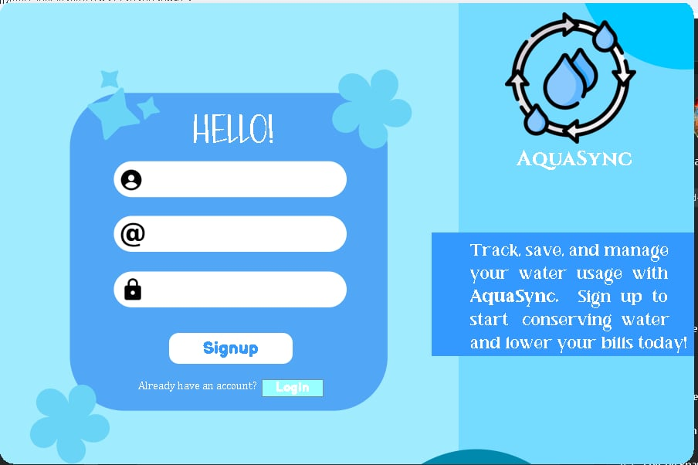

This is the sign-up window, where the user can enter their username, email, and preferred password. By clicking the "Signup" button, a new account will be created. If the user wishes to return to the login screen, they can click the "LogIn" button and enter the credentials they provided during sign-up.

Figure 6: Forgot Password Window

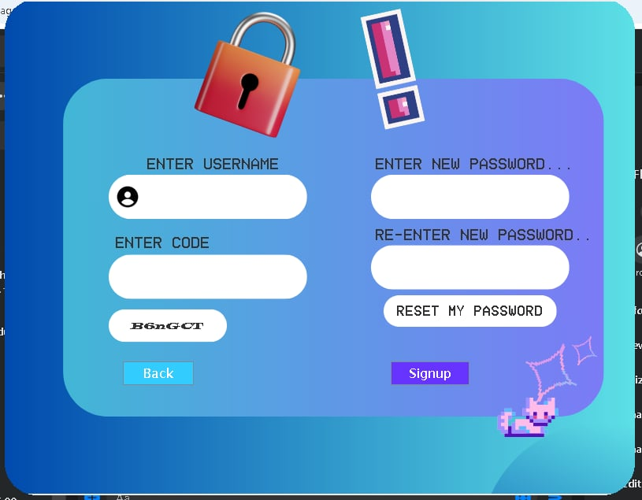

If the user clicks the "Forgot Password?" button on the login screen, they will be directed to this window. The user will enter their username and the captcha code displayed on the screen. After that, they can input a new password and click the "RESET MY PASSWORD" button. A pop-up window will appear confirming that the password reset was successful. The user can then return to the login screen and enter their credentials using the newly updated password.

Figure 7: Dashboard

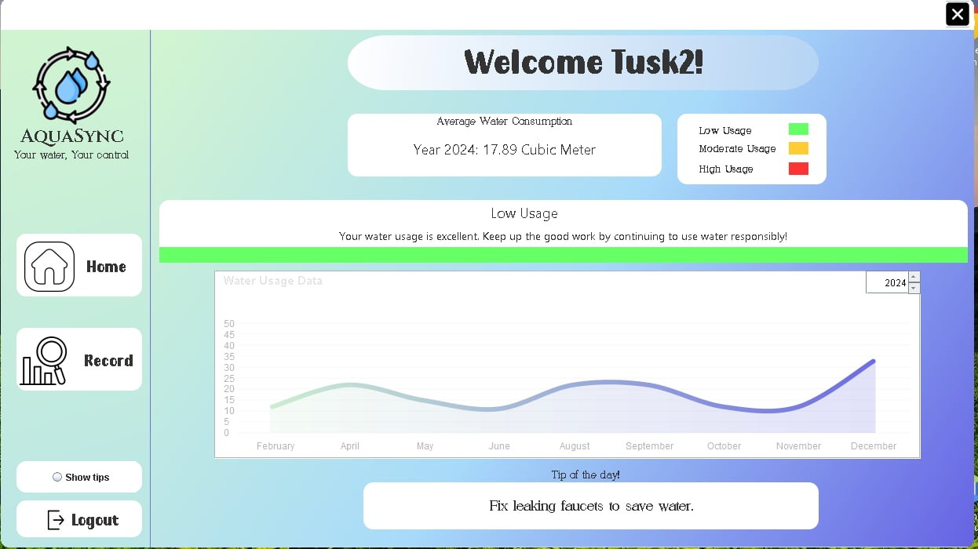

This is the main dashboard displayed upon successful login. It greets the user with a "Welcome, [Username]" message. The dashboard also shows the user's average water consumption, indicating whether their usage is low, moderate, or high. A line graph displaying the water usage entries is included, along with a section at the bottom offering helpful water-saving tips.

Figure 8: Show Tips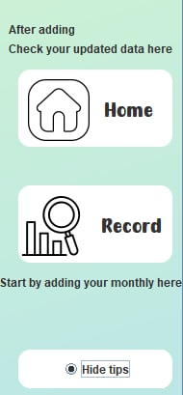

When you click the "Show Tips" radio button on the Dashboard, it will display some instructions on how to use the application.

Figure 9: Records Tab

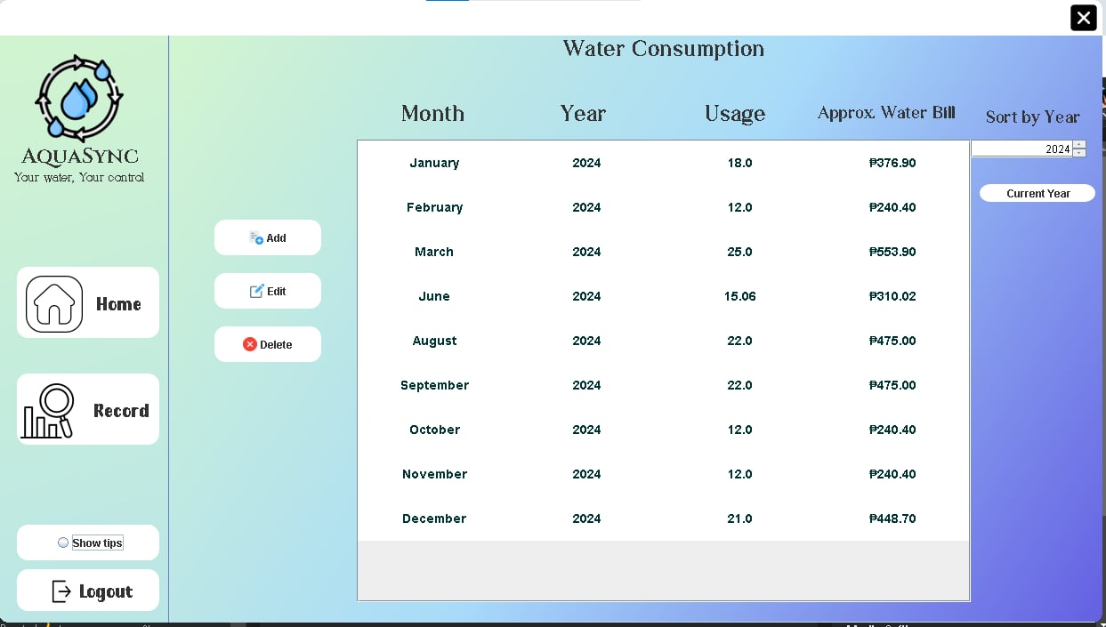

The Records tab allows you to easily add, edit, and delete your water usage records. It includes a table that displays all your entered records in a clear and organized manner. Additionally, the tab shows the approximate water bill for each record, helping you better understand your usage costs.

Figure 10: Add Record Popup Window

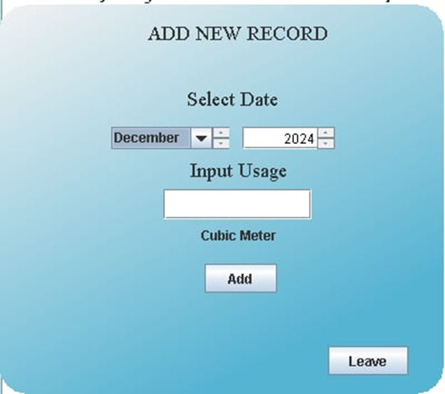

When you click the "Add" button in the Records tab, a window will appear. In this window, you can select the month and year, then input your water usage in the text field. Clicking the "Add" button will save the data to your database and display it in the table.

Figure 11: Edit Record Popup Window

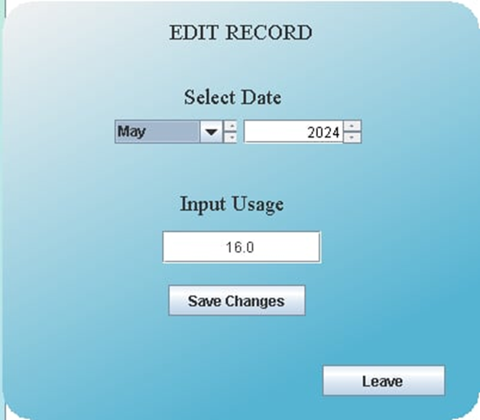

This is the Edit pop-up window, where you can modify your data. After making the necessary changes, simply click "Save Changes" to update your information. Your data will then be successfully updated.

**VII. Conclusion**

The AquaSync app serves as a practical and user-friendly solution to address the growing need for water conservation. By allowing users to monitor their monthly water usage, the app empowers individuals to make informed decisions and adopt sustainable water consumption practices. Its features, such as detailed logs, helpful tips, and easy accessibility, ensure that users can engage with the app effortlessly to take control of their water consumption habits.

This project not only aims to promote responsible water usage but also raises awareness about the importance of conserving this vital resource. AquaSync demonstrates the potential of technology in addressing environmental challenges and inspiring users to take proactive steps toward sustainable living.

**VIII. Recommendation**

1. Encourage users to monitor their water usage regularly through app notifications.
2. Add a feature to calculate and display the estimated amount of money saved based on reduced water consumption to motivate users further.
3. Introduce personalized water-saving goals to help users track their progress and stay committed.
4. Regularly update the app with practical and actionable water-saving tips to keep users informed and inspired.
5. Enhance the user interface to ensure a seamless and intuitive experience for all users.